Puritans’ Beliefs about Children

In “The Great Care of Godley Parents: Early Childhood in Puritan New England,” Gerald Moran and Maris Vinovskis write,

No aspect of New England theology has been more damaging to the historical reputation of Puritan treatment of childhood than the doctrine of infant damnation. Historians have asked, how could the Puritans have loved their children and at the same time have consigned deceased infants to eternal damnation? In theory, all infants and children who died unconverted suffered the eternal torments of hell. Since few infants were thought to experience conversion, this meant that the great majority of deceased infants were considered damned (Stannard, 1977, p. 49). The awful fate awaiting children at their demise was magnified in the minds of Puritans by their depiction of hell as a place of unremitting and unmitigated torment and horror.[1]

The reality of Puritans’ beliefs about children’s innocence or corruption was significantly more complicated, as you will see from the documents in this packet. Puritans had particular beliefs about childhood and, like any parents, expectations and hopes for their children.

**Your task today is to take a stand on this question: To what extent did Puritan parents believe in the doctrine of infant damnation?**

# Cotton Mather, Small Offers Towards the Service of the Tabernacle in this Wilderness (Boston: 1689): 59.

*The Inferiors in my Family are very* Young. *Tis too soon to begin with them; we shall only make them* take the Name of God in vain *by teaching them to* talk like Parrots *of Religion, before they can conceive better of it.*

To this I answer, *No,* you can't begin with them *Too soon.* . . They are no sooner *weaned* but they are to be *taught;* and God may give them righter and riper Conceptions of things, than you are well aware. What saies the Wise man, *Train up a* Child *in the way he should go.* Let the first liquor that is put into them be sweet and good; and they will keep the *tang* of it all their days. . .

Are they *Young?*  Yet the *Devil* has been with them already. . .*They go astray as* soon as they are born, *speaking lies.* They no sooner *step* than they *stray,* they no sooner *lisp* than they *ly.* Saran gets them to be proud, profane, reviling, as *young* as they are. And I pray, Why should not you be afore-hand with *him?*

# Headstones of Puritan Children

* Benjamin Russell (1712/3, West Tisbury, MA)
* Elizabeth Atwood (1703, Malden, MA)
* Ichabod Ackley (1764, East Haddam, CT)

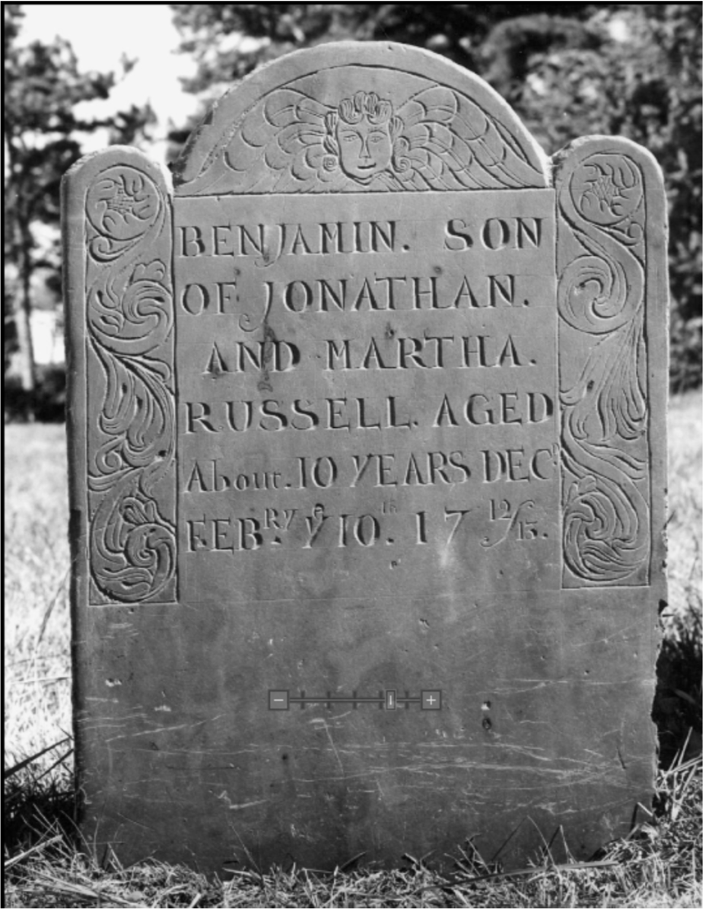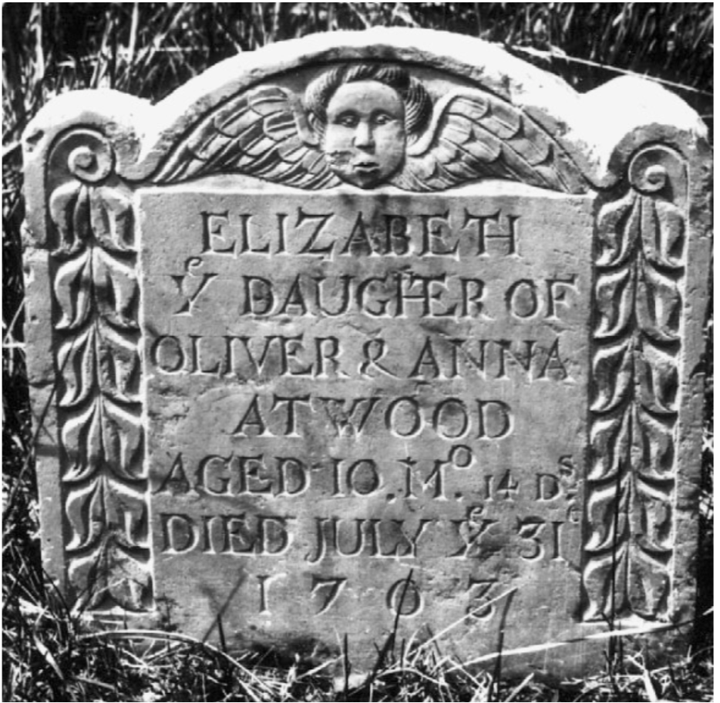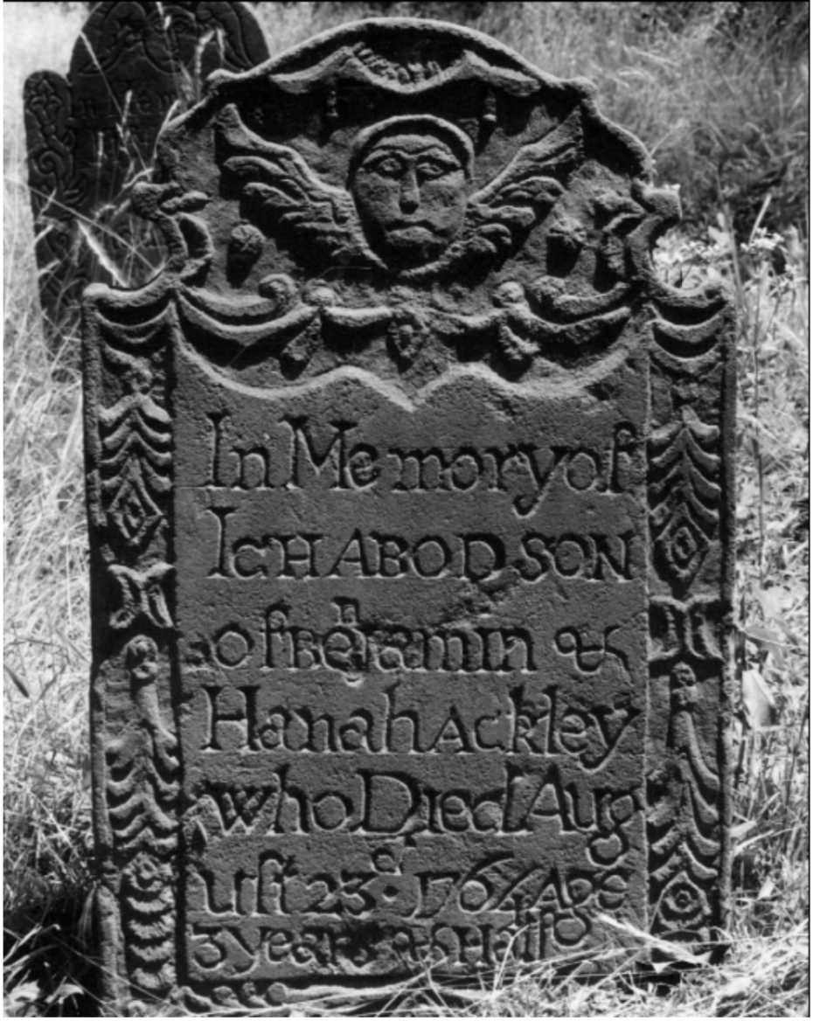

# Selected poems of Anne Bradstreet

**In Memory of My Dear Grandchild Elizabeth Bradstreet, Who Deceased August, 1665 Being a Year and a Half Old**   
Farewell dear babe, my heart's too much content,   
Farewell sweet babe, the pleasure of mine eye,   
Farewell fair flower that for a space was lent,   
Then ta'en away unto eternity.   
Blest babe why should I once bewail thy fate,   
Or sigh the days so soon were terminate;   
Sith thou art settle in an everlasting state.

By nature trees do rot when they are grown.   
And plums and apples throughly ripe do fall,   
And corn and grass are in their season mown,   
And time brings down what is both strong and tall.   
But plants new set to be eradicate,   
And buds new blown, to have so short a date,   
Is by His hand alone that guides nature and fate.

**On my dear Grandchild Simon Bradstreet, Who dyed on 16. Novemb. 1669. being but a moneth, and one day old**   
No sooner come, but gone, and fal'n asleep,   
Acquaintance short, yet parting caus'd us weep,   
Three flours, two scarcely blown, the last i'th' bud,   
Cropt by th'Almighties hand; yet is he good,   
With dreadful awe before him let's be mute,   
Such was his will, but why, let's not dispute,   
With humble hearts and mouths put in the dust,   
Let's say he's merciful as well as just.   
He will return, and make up all our losses,   
And smile again, after our bitter crosses.   
Go pretty babe, go rest with Sisters twain   
Among the blest in endless joyes remain.

# Pages from *The New England Primer* (ca.1687-90)

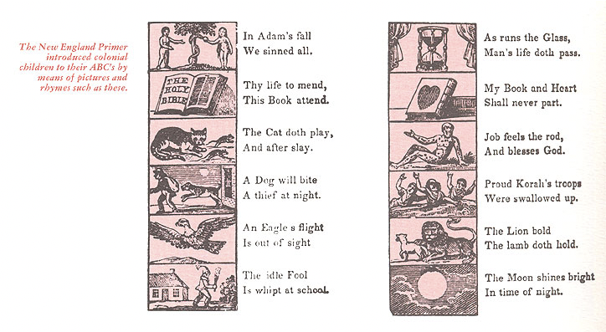

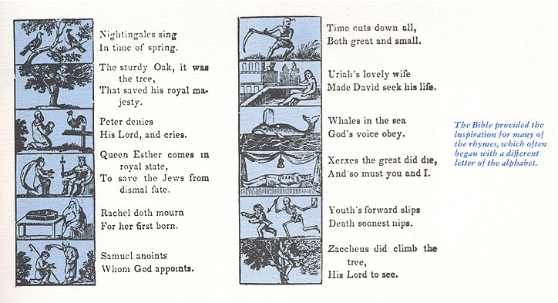

# Rules of Dorchester Schools BY THE TOWN OF DORCHESTER (1641)

THE schoolmaster shall faithfully attend his school and do his best to benefit his scholars. In this he is to use his best judgment, and not remain away from school unless necessary. This would be to the disadvantage of his scholars and would hinder their learning.   
   
 From the beginning of the first month until the end of the seventh, he shall begin to teach every day at seven of the clock in the morning. For the other five months he shall begin every day at eight of the clock in the morning and end at four in the afternoon.   
   
 Every day in the year the usual time for dismissing at noon shall be at eleven; to begin again at one.   
   
 But every second day of the week, he shall call his scholars together between twelve and one of the clock to examine them. This is to find out what they have learned the Sabbath day before. At this time he shall take notice of any wrongdoing or disorder that any of his scholars have committed on the Sabbath.   
   
 Then at some suitable time he shall instruct them how they must do at another time. Or he may punish them if the offence shall require it.   
   
 He shall equally and impartially teach such as are placed in his care. No matter whether their parents be poor or rich, he shall not refuse any who have a right and interest in the school.  
   
 Such as are placed in his care he shall faithfully teach both in the regular school studies and also in points of good manners. He shall teach them dutiful behavior to all, especially those who are their superiors.   
   
 Every sixth day of the week he shall question his scholars in the principles of Christian religion.   
   
 All men's efforts, without the blessing of God must be fruitless and unsuccessful. Therefore it is to be a chief part of the schoolmaster's duty to commend his scholars and his work to God in prayer. This he shall do morning and evening, taking care that his scholars do devoutly listen during the prayer.   
  
 The rod of correction is a rule of God necessary sometimes to be used upon children. It may easily be abused by too much severity or too much kindness. The schoolmaster shall have full power to punish all or any of his scholars, no matter who they are.   
   
 He shall do as the offence seems to require. All his scholars must be subject to this rule.   
No parent or other person living in the place shall go about to hinder the master in this.   
  
 But if any parent or others shall think there is just cause for complaint against the master for too much severity, they shall have liberty to tell him so in friendly and loving way.

1. Gerald Moran and Maris Vinovskis. “The Great Care of Godley Parents: Early Childhood in Puritan New England,” *Monographs of the Society for Research in Child Development* 50, no. 4/5 (1985): 24W37, here p. 25. http://www.jstor.org/stable/3333861.